USE CASE DIAGRAM

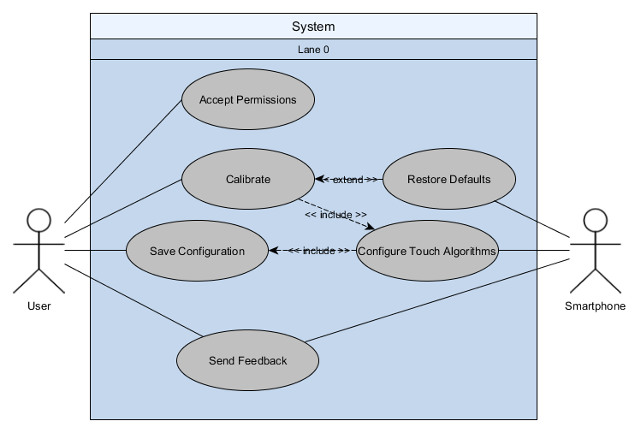

ACTIVITY DIAGRAM – TOUCH CALIBRATOR

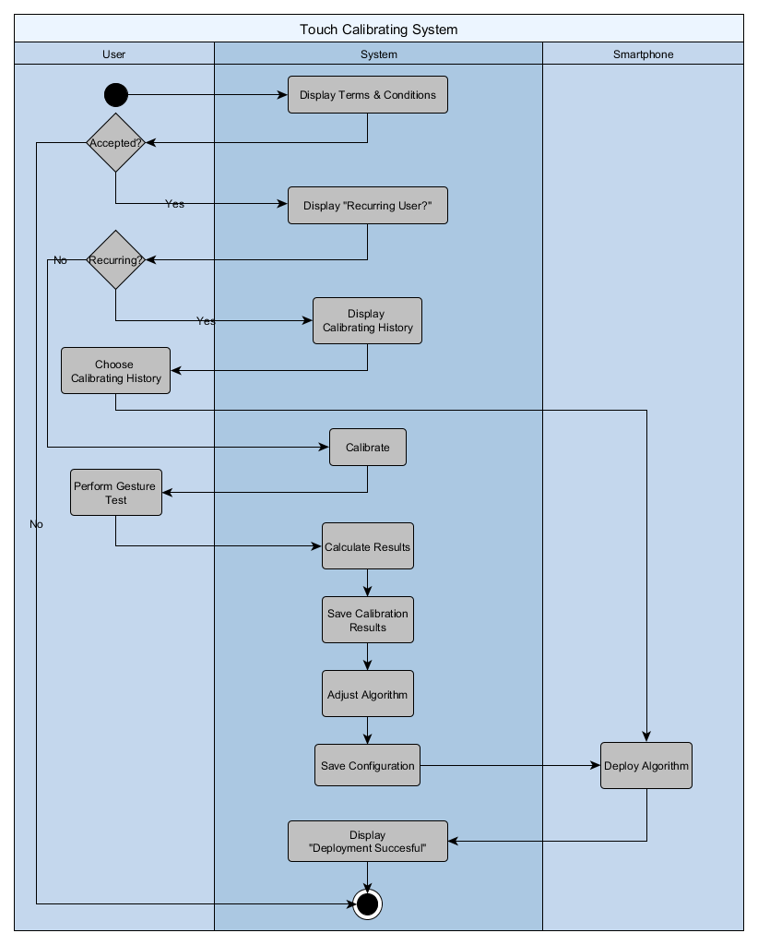

ACTIVITY DIAGRAM – FEEDBACK

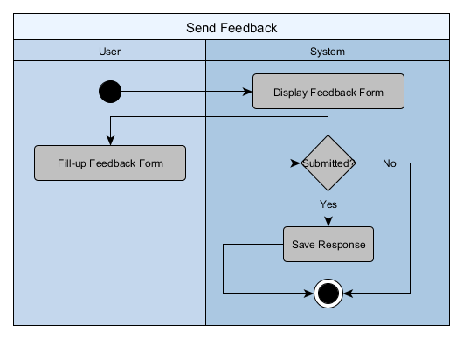

DEPLOYMENT DIAGRAM

